

Automation Selenium Installation and Execution

# **Change Log**

|  |  |  |  |
| --- | --- | --- | --- |
| Change Reason | Version | Author | Change Date |
| First Version | 1.0 | Kareem Emad | 10-04-2019 |
|  |  |  |  |

# **Introduction**

Contents

**Installation and configuration** 2

**Step 1** - Install Java on your computer. 2

**Step 2** - Install Eclipse IDE 3

**Step 3** - Install Maven. 5

**Step 4** – Install TestNG. 6

**Step 5** – Set environment variable 7

**Step 6** – Import Maven Project. 9

**Automation Framework Execution** 11

**VHL** 11

**CTA** 29

**DRL** 49

**SPL** 69

# **Installation and configuration**

**Step 1** - Install Java on your computer.

Download and install the **Java Software Development Kit (JDK)** [here](http://www.oracle.com/technetwork/java/javase/downloads/index.html)**.**

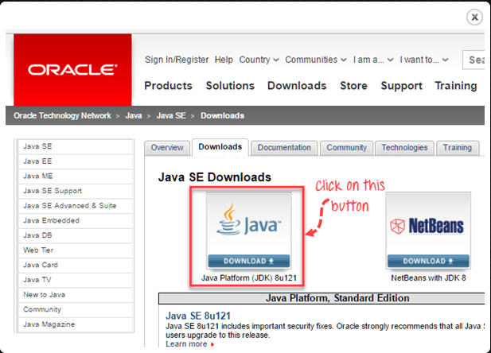

**Next –**

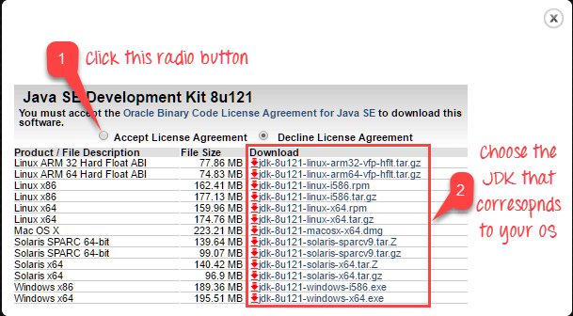

Once installation is complete, open command prompt and type “java”. If you see the following screen you are good to move to the next step.

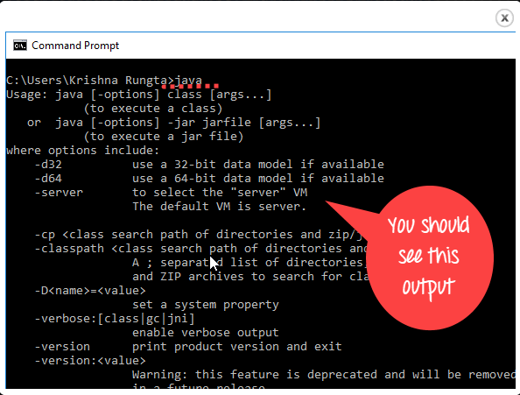

### Step 2 - Install Eclipse IDE

Download latest version of **"Eclipse IDE for Java Developers"** [here](http://www.eclipse.org/downloads/). Be sure to choose correctly between Windows 32 Bit and 64 Bit versions.

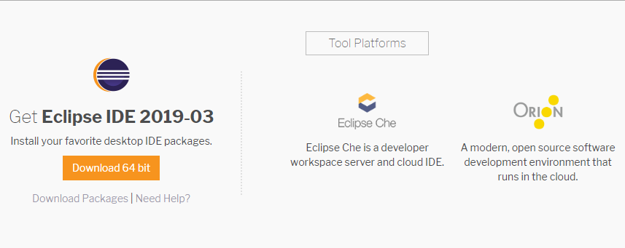

Double-click on file to Install the Eclipse. A new window will open. Click Eclipse IDE for Java Developers.

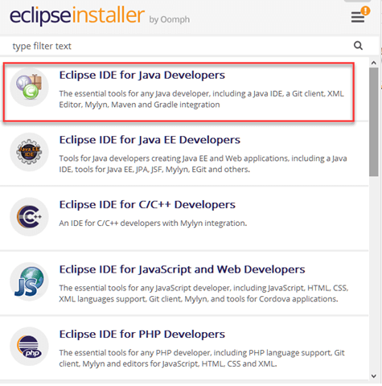

After that, a new window will open which click button marked 1 and change path to "C:\eclipse". Post that Click on Install button marked 2.

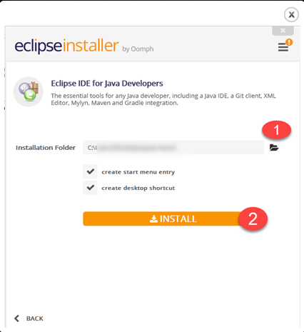

After successful completion of the installation procedure, a window will appear. On that window click on Launch.

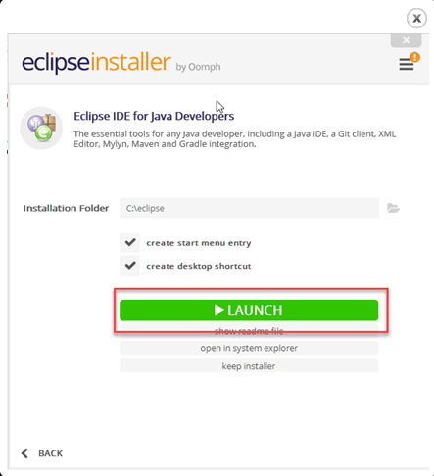

### Step 3 - Install Maven.

1. In Eclipse IDE, select **Help** | **Install New Software** from Eclipse Main Menu
2. On the Install dialog, Enter the URL <http://download.eclipse.org/technology/m2e/releases/>. Select **Work with** and m2e plugin as shown in the following screenshot:

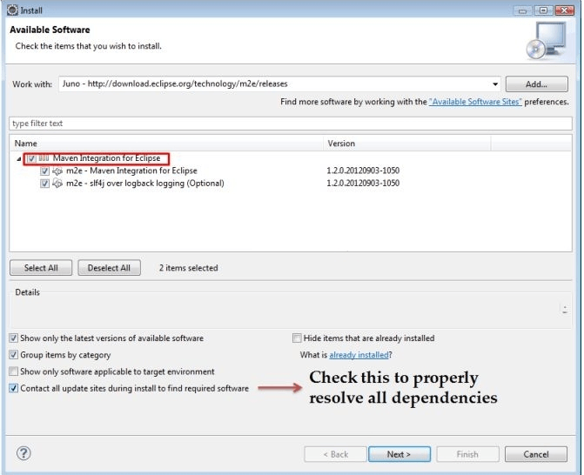

1. Click on **Next** button and finish installation.

### Step 4 – Install TestNG.

1. On the menu bar, click Help. Choose the "Eclipse Marketplace..." option.

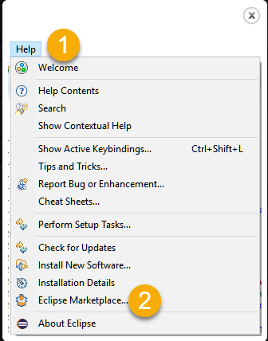

1. In the Eclipse Marketplace dialog box, type TestNG in the search box and press the search button( magnifying glass) or press enter key.
2. Click Install.

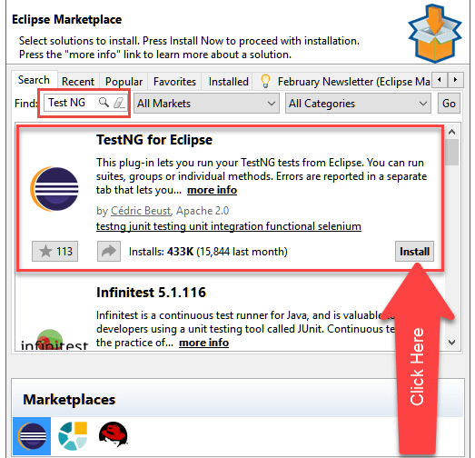

### Step 5 – Set environment variable

1. export JAVA_HOME=$(/usr/libexec/java_home)

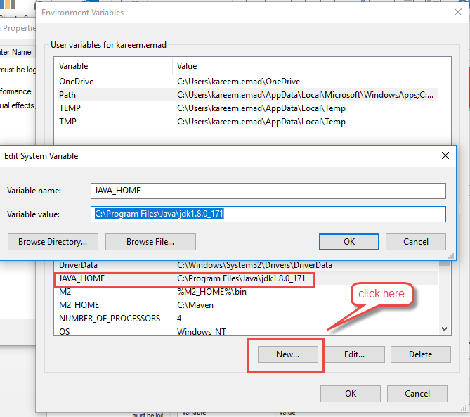

1. export M2_HOME=/Users/ghassan/Documents/apache-maven-3.3.9

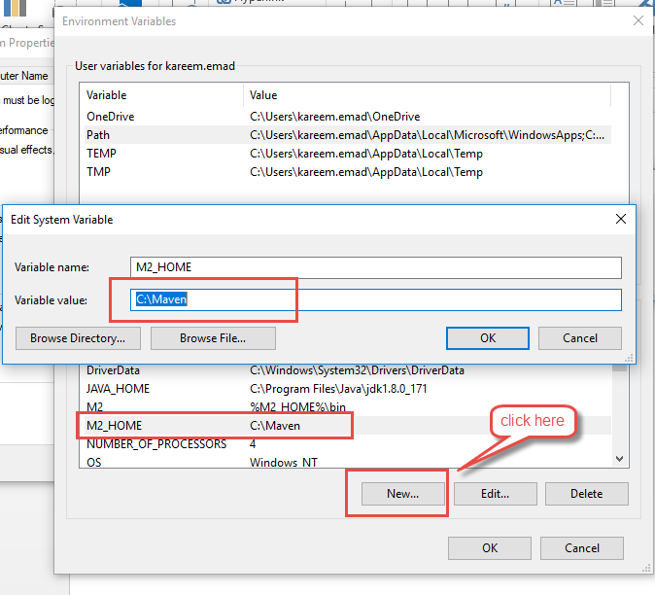

1. export M2=$M2_HOME/bin

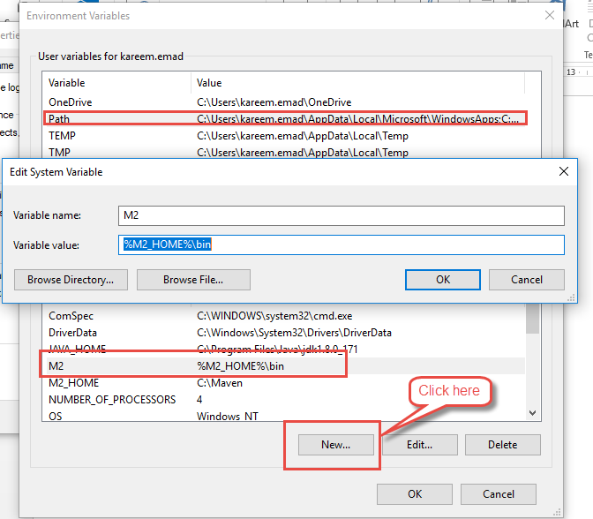

1. export PATH=$M2:$PATH

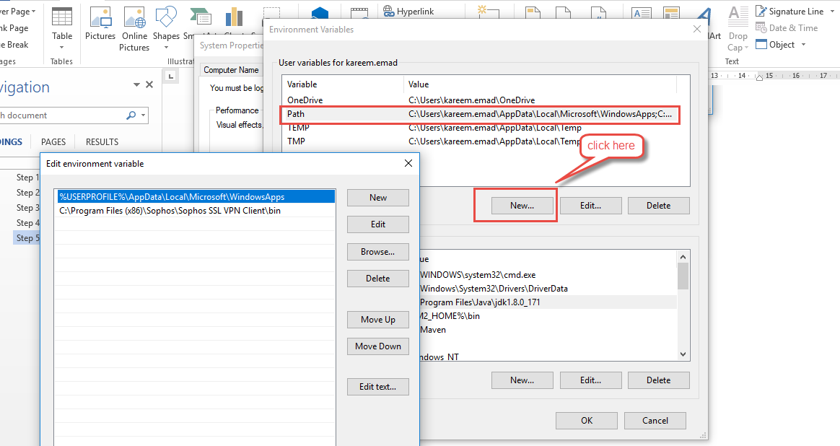

### Step 6 – Import Maven Project.

1. From the File menu, select Import. The Select screen opens.
2. Expand Maven and select Existing Maven Projects.

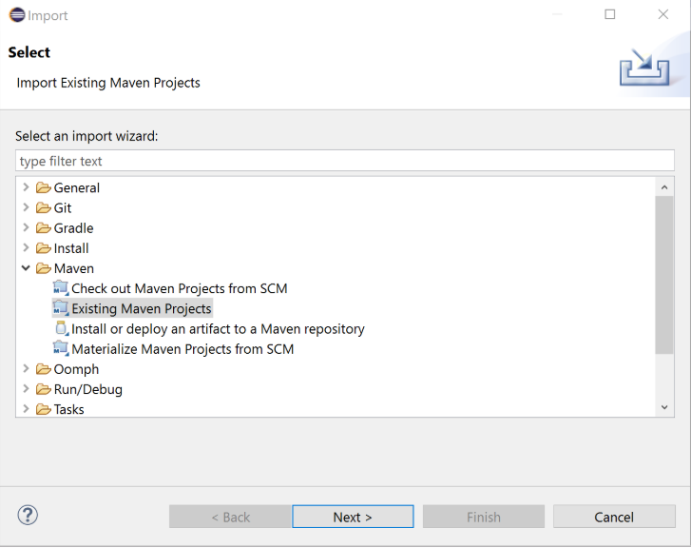

1. Click Next.
2. For Root Directory, click Browse and select the top-level project folder.

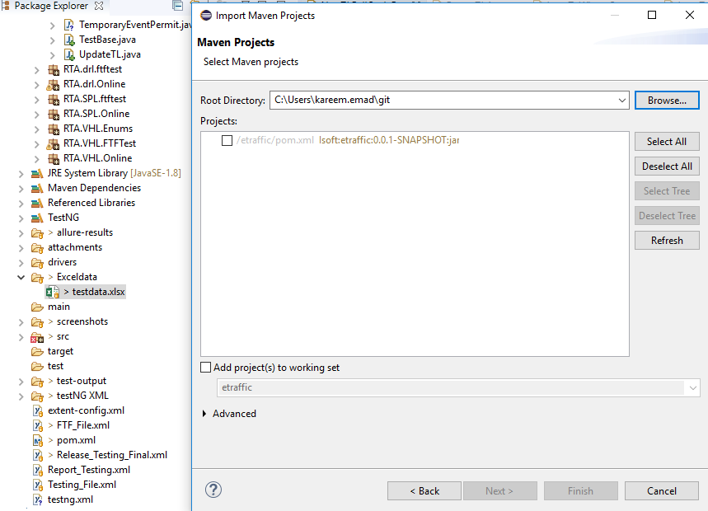

1. Verify that the Projects list includes all subprojects and click Finish.

# **Automation Framework Execution**

### VHL

#### Execution VHL Smoke.

1. Navigate to /etraffic_CI
2. Click on /src/main/java
3. Click on isoft/etraffic/testrunner
4. Right Click on WindowApp.java
5. Select Run As, Java Application

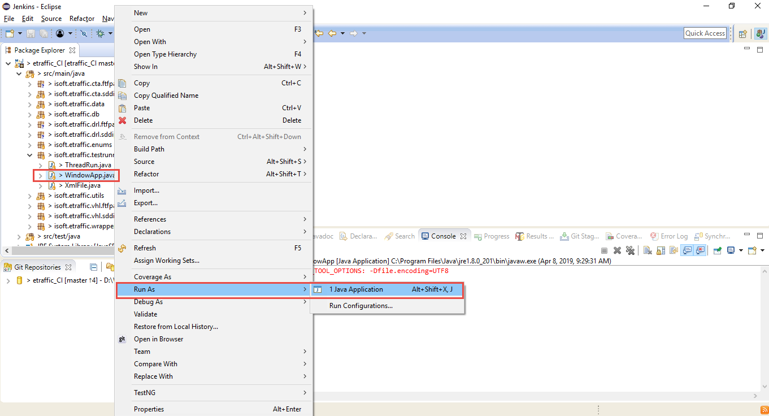

New Window will opened as below.

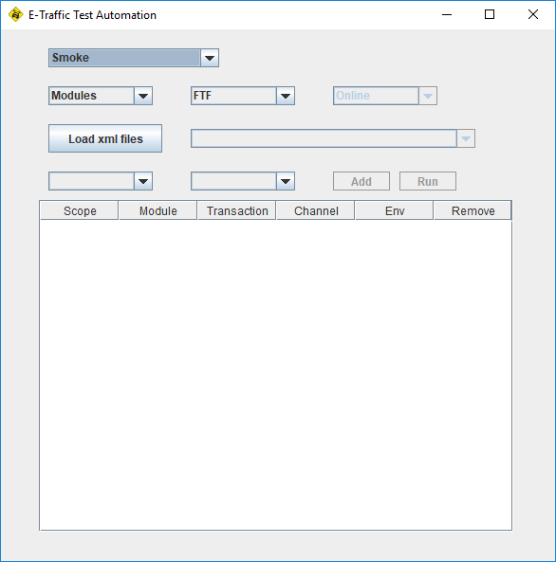

1. Select Scope By Smoke

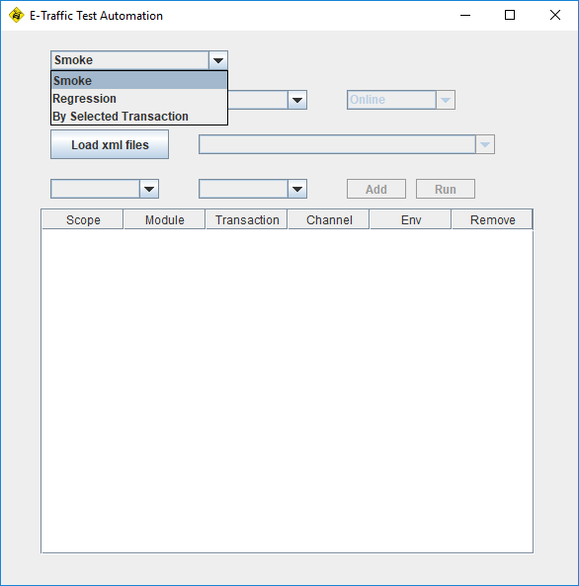

1. Select Modules VHL

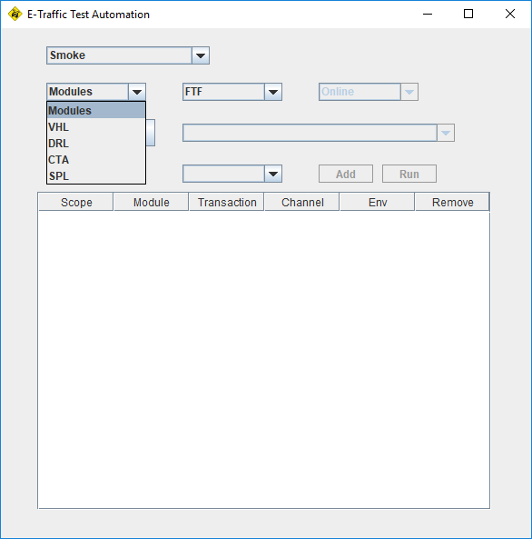

1. Select Channel (FTF or SDDI)

In case SDDI, you will have four options (Online, Public Access, Trusted Agent, Call Centre).

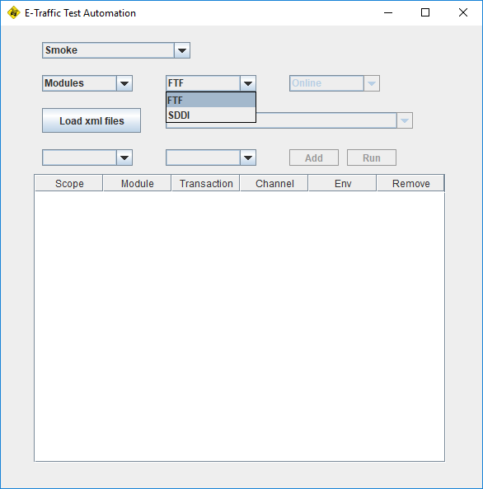

1. Click on Load XML Files

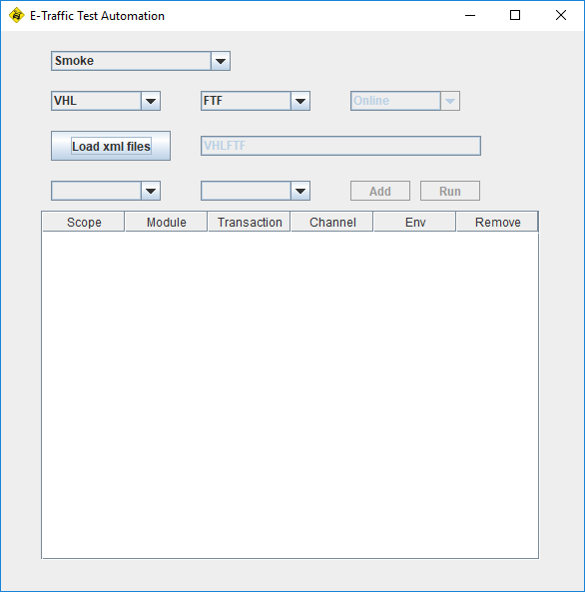

1. Select Environment (ER,STG, UAT, DEV)

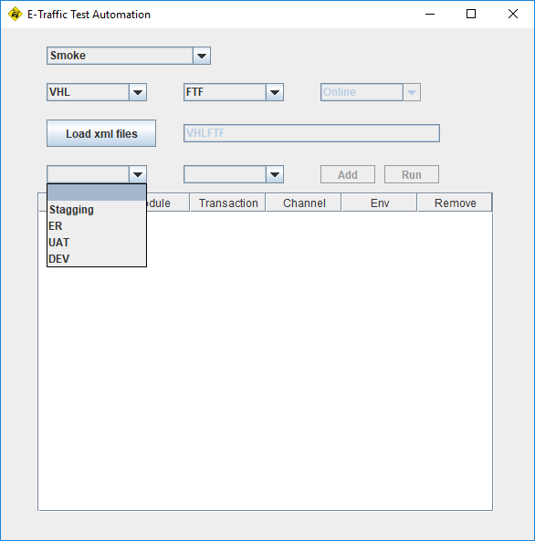

1. Select Data Base (Test1 or Test2).

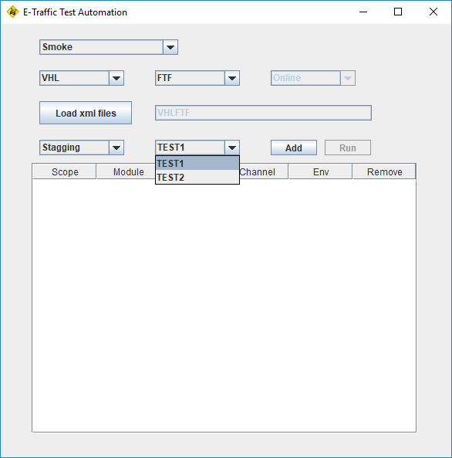

1. Click on Add Button.

It will add new row as shown, repeat the above steps from step No 8 to step No 13, to add more test cases.

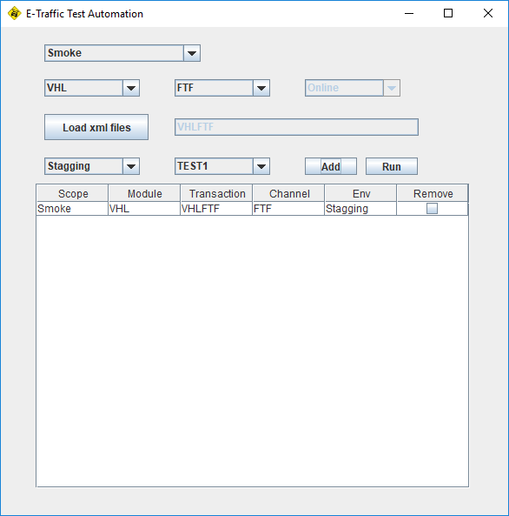

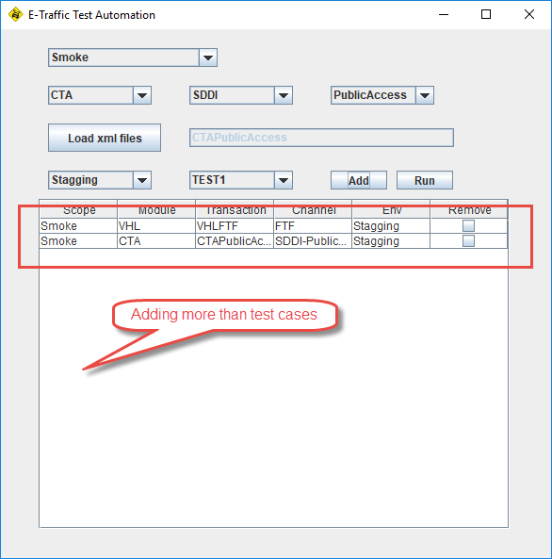

To delete test case, just click on check box as below.

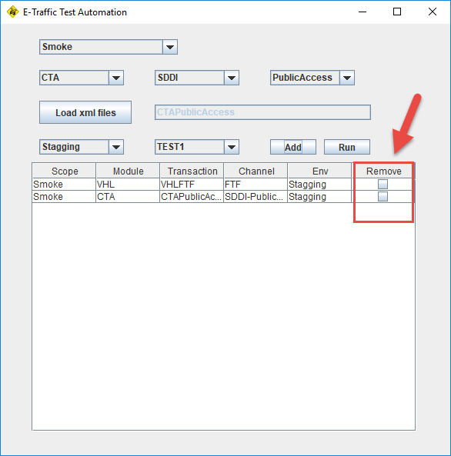

1. Click on Run Button, to execute test cases selected. Then click on Yes button.

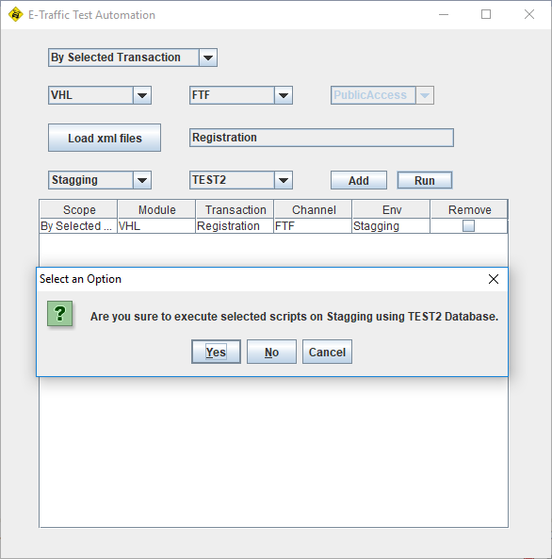

The Console will display the below Log, that mean automation test start executed.

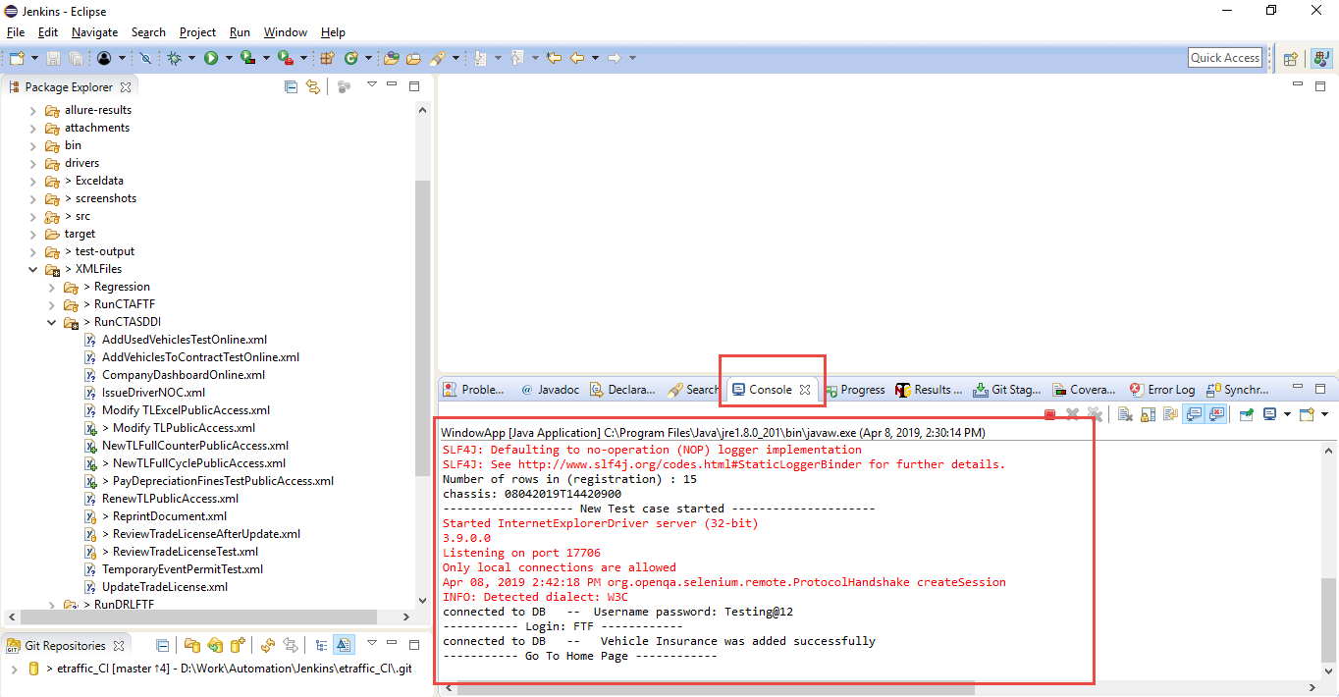

#### Execution VHL Regression.

1. Select Scope Regression

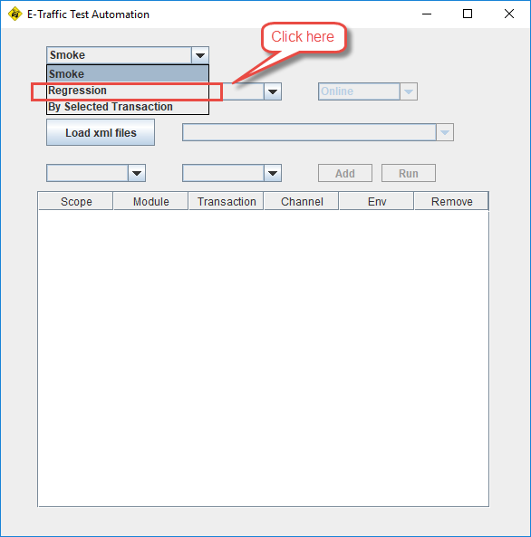

1. Select Modules VHL



1. Select Channel (FTF or SDDI)

In case SDDI, you will have four options (Online, Public Access, Trusted Agent, Call Centre).



1. Click on Load XML Files



1. Select Environment (ER,STG, UAT, DEV)



1. Select Data Base (Test1 or Test2).



1. Click on Add Button.

It will add new row as shown, repeat the above steps from step No 8 to step No 13, to add more test cases.





To delete test case, just click on check box as below.



1. Click on Run Button, to execute test cases selected. Then click on Yes button.



The Console will display the below Log, that mean automation test executed.



#### Execution VHL By Transaction.

1. Select Scope By Selected Transaction

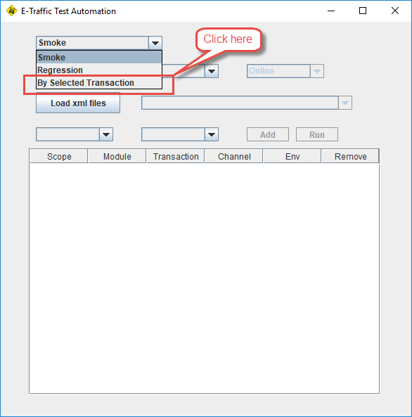

1. Select Modules VHL



1. Select Channel (FTF or SDDI)



In case SDDI, you will have four options (Online, Public Access, Trusted Agent, Call Centre).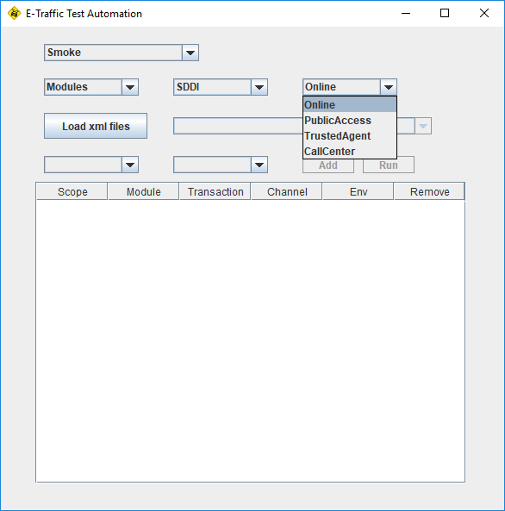

1. Click on Load XML Files and select test case you want to run

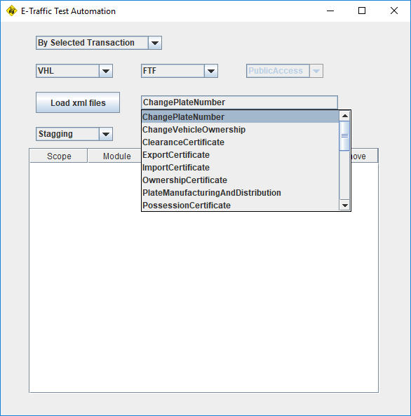

1. Select Environment (ER,STG, UAT, DEV)



1. Select Data Base (Test1 or Test2).



1. Click on Add Button.

It will add new row as shown, repeat the above steps from step No 8 to step No 13, to add more test cases.





To delete test case, just click on check box as below.



1. Click on Run Button, to execute test cases selected. Then click on Yes button.



The Console will display the below Log, that mean automation test executed.

### CTA

#### Execution CTA Smoke.

1. Navigate to /etraffic_CI
2. Click on /src/main/java
3. Click on isoft/etraffic/testrunner
4. Right Click on WindowApp.java
5. Select Run As, Java Application



New Window will opened as below.



1. Select Scope By Smoke
2. Select Modules CTA



1. Select Channel (FTF or SDDI)

In case SDDI, you will have four options (Online, Public Access, Trusted Agent, Call Centre).



1. Click on Load XML Files



1. Select Environment (ER,STG, UAT, DEV)



1. Select Data Base (Test1 or Test2).



1. Click on Add Button.

It will add new row as shown, repeat the above steps from step No 8 to step No 13, to add more test cases.





To delete test case, just click on check box as below.



1. Click on Run Button, to execute test cases selected. Then click on Yes button.



The Console will display the below Log, that mean automation test start executed.



#### Execution CTA Regression.

1. Select Scope Regression



1. Select Modules CTA



1. Select Channel (FTF or SDDI)

In case SDDI, you will have four options (Online, Public Access, Trusted Agent, Call Centre).



1. Click on Load XML Files



1. Select Environment (ER,STG, UAT, DEV)



1. Select Data Base (Test1 or Test2).



1. Click on Add Button.

It will add new row as shown, repeat the above steps from step No 8 to step No 13, to add more test cases.





To delete test case, just click on check box as below.



1. Click on Run Button, to execute test cases selected. Then click on Yes button.



The Console will display the below Log, that mean automation test executed.



#### Execution CTA By Transaction.

1. Select Scope By Selected Transaction



1. Select Modules CTA



1. Select Channel (FTF or SDDI)



In case SDDI, you will have four options (Online, Public Access, Trusted Agent, Call Centre).

1. Click on Load XML Files and select test case you want to run



1. Select Environment (ER,STG, UAT, DEV)



1. Select Data Base (Test1 or Test2).



1. Click on Add Button.

It will add new row as shown, repeat the above steps from step No 8 to step No 13, to add more test cases.





To delete test case, just click on check box as below.



1. Click on Run Button, to execute test cases selected. Then click on Yes button.



The Console will display the below Log, that mean automation test executed.



### DRL

#### Execution DRL Smoke.

1. Navigate to /etraffic_CI
2. Click on /src/main/java
3. Click on isoft/etraffic/testrunner
4. Right Click on WindowApp.java
5. Select Run As, Java Application



New Window will opened as below.



1. Select Scope By Smoke
2. Select Modules DRL



1. Select Channel (FTF or SDDI)

In case SDDI, you will have four options (Online, Public Access, Trusted Agent, Call Centre).



1. Click on Load XML Files



1. Select Environment (ER,STG, UAT, DEV)



1. Select Data Base (Test1 or Test2).



1. Click on Add Button.

It will add new row as shown, repeat the above steps from step No 8 to step No 13, to add more test cases.





To delete test case, just click on check box as below.



1. Click on Run Button, to execute test cases selected. Then click on Yes button.



The Console will display the below Log, that mean automation test start executed.



#### Execution DRL Regression.

1. Select Scope Regression



1. Select Modules DRL.



1. Select Channel (FTF or SDDI)

In case SDDI, you will have four options (Online, Public Access, Trusted Agent, Call Centre).



1. Click on Load XML Files



1. Select Environment (ER,STG, UAT, DEV)



1. Select Data Base (Test1 or Test2).



1. Click on Add Button.

It will add new row as shown, repeat the above steps from step No 8 to step No 13, to add more test cases.





To delete test case, just click on check box as below.



1. Click on Run Button, to execute test cases selected. Then click on Yes button.



The Console will display the below Log, that mean automation test executed.



#### Execution DRL By Transaction.

1. Select Scope By Selected Transaction



1. Select Modules DRL



1. Select Channel (FTF or SDDI)



In case SDDI, you will have four options (Online, Public Access, Trusted Agent, Call Centre).

1. Click on Load XML Files and select test case you want to run



1. Select Environment (ER,STG, UAT, DEV)



1. Select Data Base (Test1 or Test2).



1. Click on Add Button.

It will add new row as shown, repeat the above steps from step No 8 to step No 13, to add more test cases.





To delete test case, just click on check box as below.



1. Click on Run Button, to execute test cases selected. Then click on Yes button.



The Console will display the below Log, that mean automation test executed.



### SPL

#### Execution SPL Smoke.

1. Navigate to /etraffic_CI
2. Click on /src/main/java
3. Click on isoft/etraffic/testrunner
4. Right Click on WindowApp.java
5. Select Run As, Java Application



New Window will opened as below.



1. Select Scope By Smoke
2. Select Modules SPL



1. Select Channel (FTF or SDDI)

In case SDDI, you will have four options (Online, Public Access, Trusted Agent, Call Centre).



1. Click on Load XML Files



1. Select Environment (ER,STG, UAT, DEV)



1. Select Data Base (Test1 or Test2).



1. Click on Add Button.

It will add new row as shown, repeat the above steps from step No 8 to step No 13, to add more test cases.





To delete test case, just click on check box as below.



1. Click on Run Button, to execute test cases selected. Then click on Yes button.



The Console will display the below Log, that mean automation test start executed.



#### Execution SPL Regression.

1. Select Scope Regression



1. Select Modules SPL.



1. Select Channel (FTF or SDDI)

In case SDDI, you will have four options (Online, Public Access, Trusted Agent, Call Centre).



1. Click on Load XML Files



1. Select Environment (ER,STG, UAT, DEV)



1. Select Data Base (Test1 or Test2).



1. Click on Add Button.

It will add new row as shown, repeat the above steps from step No 8 to step No 13, to add more test cases.





To delete test case, just click on check box as below.



1. Click on Run Button, to execute test cases selected. Then click on Yes button.



The Console will display the below Log, that mean automation test executed.



#### Execution SPL By Transaction.

1. Select Scope By Selected Transaction



1. Select Modules SPL



1. Select Channel (FTF or SDDI)



In case SDDI, you will have four options (Online, Public Access, Trusted Agent, Call Centre).

1. Click on Load XML Files and select test case you want to run



1. Select Environment (ER,STG, UAT, DEV)



1. Select Data Base (Test1 or Test2).



1. Click on Add Button.

It will add new row as shown, repeat the above steps from step No 8 to step No 13, to add more test cases.





To delete test case, just click on check box as below.



1. Click on Run Button, to execute test cases selected. Then click on Yes button.



The Console will display the below Log, that mean automation test executed.

